 | PASTOR
 | FR. TOM WYRSCH
 | 314.434.4211 #336
 | FRWYRSCH@STMONICASTL.ORG
 | RETIRED PRIEST IN RESIDENCE
 | FR. TIM FOLEY
 | REGULAR WEEKEND CELEBRANT
 | FR. GEORGE BRENNAN
 | PERMANENT DEACONS
 | DEACON CARL SOMMER
 | CARL SOMMER@ARCHSTL.ORG AND
 | DEACON BILL SMITH
 | BSMITH@STMONICASTL.ORG
 | RETIRED DEACONS
 | ROBERT BIRKENMAIER AND
 | JIM MARTIN…..JIM@JPMLLC.COM
ST. MONICA CHURCH 12136 OLIVE BLVD CREVE COEUR, MO WWW.STMONICASTL.ORG | SUNDAY MASS TIMES  SATURDAY VIGIL 5:00 P.M. SUNDAY 7:30 A.M., 9:30 A.M., 11:30 A.M.
 | DAILY WEEKDAY MASS
 | PLEASE SEE SCHEDULE ON PAGE 3
 | CONFESSIONS
 | 3:30–4:30 P.M. SATURDAY OR
 | BY APPOINTMENT
 | ADORATION
 | WEDNESDAY 9:00 A.M.–9:00 P.M.
 | BAPTISMS
 | CELEBRATED 1ST AND 3RD SUNDAY OF
 | THE MONTH OR BY APPOINTMENT
PARISH CONTACT INFORMATION
—
LITURGICAL MUSIC DIRECTOR—HEATHER MARTIN COOPER…314.434.2173 #6 HMCOOPER@STMONICASTL.ORG
ST. MONICA SCHOOL GRADES PRESCHOOL—8TH
PRINCIPAL—TAMMI ROHMAN…314.434.2173…..TROHMAN@STMONICASTL.ORG SCHOOL SECRETARY—GAYLE DRYDEN…314.434.2173…..GDRYDEN@STMONICASTL.ORG PSR (PARISH SCHOOL OF RELIGION)—TAMMI ROHMAN
SAFE ENVIRONMENT—ANNE COERVER…314.434.4211 #331 ACOERVER@STMONICASTL.ORG
PARISH COUNCIL CHAIRPERSON—MARK HAMPTON
PARISH COUNCIL @STMONICASTL.ORG
ST. VINCENT DE PAUL ASSISTANCE LINE…314.289.6101. Mailbox #2210
MAINTENANCE—DON SMITHHART…MAINTENANCE@STMONICASTL.ORG ATHLETIC DIRECTOR—JOE GIBSON...314.504.0775. SAINTMONICASPORTS@GMAIL.COM
PTO PRESIDENT—ROSEMARY SHAW...314.640.7986. ROSEMARY.SHAW@SBCGLOBAL.NET
WELCOME TO ST. MONICA PARISH
April 3, 2022

A Message from the Pastor…………..

VIsIONING DAY was a very exciting day, one of our best parish days, as I’ve seen elsewhere. About a hundred parishioners were in our double-room hall downstairs, to reflect on the strong areas of the parish, and those that may need improvement (our facilitator Vince Estrada calls these “opportunities”.) Tables made lists of these on large sheets, which were then taped to the wall so everybody could go to the others’ sheets and “vote” on the strengths and opportunities. Throughout the day, longtime parishioners, and those not so long, came up to thank me for this opportunity. I’m well aware that with a succession of pastors in a brief time, many found it hard to sense priorities or direction for the parish. That’s just what this has start- ed. All will have a chance to complete a survey in church after Easter based on the priorities produced this day, and there will be more participatory days to complete a plan. Stay tuned and keep your voice in this process. Great thanks for this powerful parish day go to our Visioning Day Committee: Lynn Barnes, Vicki Westall, Sara Peters (soon Anastacio), Heather Martin Cooper and Jim McCullough.
CONFIRMATION was another strong parish day this past Tuesday. We had young people from our grade school, from PSR, and homeschooled. It’s great for me to see people at this critical age choose to live their life in Christ, and in the church. Educators say this is the age that we can first envision a true life future ahead of us, and make choices. Their names will be in the bulletin next week, and I ask you to pray for them. Bishop Rivituso was, as always, a very kind, warm, and spiritual leader of this service.
Today we conclude our mini-seminar on conversion with The Raising of Lazarus. It’s so deep I’m some- what at a loss to interpret it. But I know it has to do with hope—not only the hope of Lazarus getting a new life, but the hope of his sisters. They were angry with Jesus, disappointed that he hadn’t prevented this terrible loss in their life. But Jesus’ intent was to lead them, not around it, but through it. So, he said to her, right in her grief: “I am the Resurrection. Do you believe this?” Her answer can be ours.
At this late time of Lent, then, evaluate if you’ve had movement on the harder things of Lent—prayer, trust in God, confidence, courage , love. Monday night (tomorrow) is our communal Lenten Penance Service at 7:00 P.M., with several confessors including monks from St. Louis Abbey (St. Anselm’s).
Confession is a great way to examine yourself and set your direction on an even more faith-filled, loving direction.
Fr. Tim Foley has come in as a retired priest in residence. St. Monica was his choice to continue his retirement at. I will enjoy his company. There is no change to our daily Mass schedule while he settles in and rests from the move. This will continue till after Easter.
We received a very generous gift from the Living Trust of Harold J. Bauer. WE thank her and parishioner Jean Chartrand for remembering the parish.
Next week is Holy Week, and the Easter Triduum. I can sense I’m clearing space as always to enter the Paschal Retreat, with a priority on reflecting on the Death and Resurrection of Christ more than busi- ness as usual. This will be my entire focus starting next Sunday. Please support Fr. Tim and me to be where we can be best for you and the parish from here to Easter, let’s begin to hold off the non-essential things and be fully present to the greatest week of our faith.
Fr. Wyrsch

PARISH STEWARDSHIP MARCH 27: Envelopes $11,308.00; Loose $362.00; Online Giving $7,990.20; Catholic Relief Services $262.00; Flowers $115.00; Pro-Life $50.00;Retired Priests $250.00; School
$85.00; St. Vincent De Paul $620.00; Special Donation $25.00 and Tithing for the Poor $40.00.

MASS INTENTIONS–APRIL 4-10
MONDAY APRIL 4
6:30 A.M. COMMUNION SERVICE
8:15 A.M. MARIA KLUMP
TUESDAY APRIL 5 6:30 A.M. JOHN LANG WEDNESDAY APRIL 6
6:30 A.M. COMMUNION SERVICE
8:15 A.M. DR. SYL FLOTTE AND HIS DAUGHTER, MARY
THURSDAY APRIL 7
6:30 A.M. RICHARD SANDER JR
FRIDAY APRIL 8
6:30 A.M. JOHN J. MERCURIO
SATURDAY APRIL 9
5:00 P.M. ROBERT F. PETERSON

SUNDAY PALM SUNDAY OF THE PASSION OF THE LORD
7:30 A.M. PRAYER FOR THE PEOPLE
9:30 A.M. SHERMAN FAMILY
11:30 A.M. SPECIAL INTENTION
WEEKDAY MASS SCHEDULE:
6:30: MASS TUESDAY, THURSDAY AND FRIDAY COMMUNION SERVICE MONDAY WEDNESDAY
8:15 MASS MONDAY AND WEDNESDAY (SCHOOL MASS)
NO A.M. MASS SATURDAY SAT. EVE-SUNDAY A.M. NO CHANGE

PRAYERS FOR HEALING……
Shirley Dunker, Bill Guiot, Christina Hartley, Bob Huseman, Donna Jones, Terri Janon, Patricia Kurane, Gavin Lain, Patricia Mohan, Armida Morales,
Joe Mueller, Susan Pribe, Tony Rosas, Candy Ross, Helen Sander, Beth Schobel, Rose Slee and Marilyn Williams.

CONGRATULATIONS TO
Renee Michelle Spann and McKenna Catherine Spann, daughters of Michael and Catherine Spann and to Thea Marie Piening, daughter of Kurt and
Stefanie Piening who were recently baptized into our Parish Community.

ADORATION
Find peace in the warmth of Christ at our 24 hour Eucharistic Adoration Wednesdays 9:00 A. M. to 9:00 P.M. Questions, contact Barb DeJean at de_jean@sbcglobal.net

(ROAR) RETAILERS OFFERING ADDED REWARDS
What a wonderful program this is! Get your gift cards to help fill those Easter Baskets this year. It’s simple, quick and helps your Parish out in the bargain.
This program is our ongoing Parish Fundraiser available after all Masses. Questions call, MJ at 314.434.3312.

CBC SUMMER ACADEMY REGISTRATION open for
all boys entering 6, 7, and 8 grades. Enjoy a premier summer experience held in CBC’s theater, classrooms, science labs, art studios, and sports facilities by being part of our CBC Summer Academy. Register today www.BeaCadet.org/summer. Contact Melissa Ryan ryanm@cbchs.org or 314.985.6095 for information.

HOST FAMILIES
Looking for host families for high school exchange students coming from Europe, Asia and South America in August. Please contact Celia for more information for this rewarding experience.
Email ccteach6@sbcglobal.net or call 314.973.1802. Thanks you in advance.

LILY PLANTS
Orders for Easter Lily Plants can be sent to the Parish Office or in the collection basket this weekend. Order deadline is Monday, April 4 by noon. The Ladies Guild

ST. MONICA CATHOLIC CHURCH BLOOD DRIVE
Masks and appointments required!
Give and get a gift card.
A TREE PLANTED IN YOUR NAME!
Date: Sunday, May 1 from 8:00 A.M. - 1:00 P.M. in the St. Monica Gym.
Schedule your appointment today! https//login.bloodcenter.org/donor/schedules/ drive_schedule/107108
Thanks in advance for your help and we hope to see you at the drive!
UPCOMING EARLY BULLETIN DEADLINES
Due to the Easter Season
April 17 by Wednesday, April 6
Thank you in advance

KNIGHTS OF COLUMBUS
Bingo Saturday, April 23, 7:00 P.M. at St. John Bosco. Doors open at 6:00 P.M. Admission $20 in advance/
$25 at the door and includes a packet of bingo cards, snacks and drinks. Proceeds benefit the Knights of Columbus campaign to assist Ukraine via the Ukraine Solidarity Fund. Support this
effort directly at KofC.org Reservations call Troy 314.469.1132.

SAINT MONICA GOLF TOURNAMENT
Hosted by the Knights of Columbus and PTO.
All proceeds from the tournament will go to support our school with a portion of the proceeds going to sup- port the 2023 Pro Life Trip.
Tournament Day: May 16, Rainout day: May 23 Where: Sugar Creek Golf Course
5224 Country Club Dr House Springs, MO Tournament begins at 8:00 A.M. Entry fee $150/player $600/team
We will also be looking for volunteers for the tournament. For information or questions contact Richard Appelbaum 314.201.4240, email Richardappelbaum18@gmail.com
or by Fast Direct.

THE RUN FOR LIFE AND LEARNING,
BENEFITING BIRTHRIGHT STL, IS JUNE 4!
Join us at Creve Coeur Lake for a chip-timed
6K Run/Walk, 1 Mile Fun Walk/Run, and ¼ Mile Kids Run with Fredbird. Register or donate at runsig- nup.com/run4lifeandlearning. Proceeds enable women who are financially stressed by an unplanned pregnancy to continue their education and secure better lives for themselves and their families.

CELEBRATE 100 YEARS OF WHITE HOUSE RETREAT TUESDAY, APRIL 26.
100th Anniversary Dinner Celebration at the historic Chase Park Plaza Hotel in the Khorassan Ballroom. Doors open at 6:00 P.M. and concludes at 9:00 P.M. Space is limited and tickets must be purchased in advance. Individual tickets are on sale now for $125. Tables of 10 are available at the discounted price of
$1000 (save $250).
To purchase a ticket or table for this event, call 314.416.6400.
For more information on White House Retreat, Visit whitehouseretreat.org

ST. VINCENT DE PAUL FOOD PANTRY NEEDS:
To meet ongoing needs of our neighbors, our food pantry would hope to replenish our stock of the following items:
canned greens, mixed vegetables, canned pineapple, green beans, mouthwash, tooth paste and evaporated milk

CATHOLIC CEMETERIES
To maintain the reverence of Catholic Cemeteries sacred spaces, our team removes decorations from gravesites monthly. See the schedule below to plan accordingly. For the rest of the 2022 year:
April 13-14, May 18-19, June 8-9, July13-14,
August 10-11, September 14-15, October12-13, and November 16-17. Be assured of our prayers for you, and for those who have passed into everlasting life.

Thank you from Catholic Cemeteries.

ZECHARIAH MEN'S PRAYER BREAKFAST
Fellowship, talks, and prayer. Fleur de Lis Room seat- ing, Cardinal Rigali Center, is by reservation only. Email gary.whitlock@att.net, or 636.215.0973.
The online form is StlRenewal.Org/ZPB. $15 for breakfast at 9:00 A.M. is payable at the door or tune in for free at 10:00 A.M. on YouTube or Facebook, stlrenewal.org/yt or stlrenewal.org/fb
For information visit ARCHSTL.ORG/RENEWAL

PARENTS
We encourage you to seek a blessing for your small children when they accompany you to Holy Communion. If possible, hold them or stand them in front of you so that we can bless them. Thank you!
BULLETIN DEADLINE AND INFORMATION
All items must be submitted no later than 8:00 A.M. Monday for publication (unless otherwise noted) in the following weeks bulletin.

Our publishing company updates E-BULLETINS
weekly and sends them out to subscribers. To subscribe, visit ebulletin.jspaluch.com Enter zip code 63141, choose St. Monica,
use your email address to receive St. Monica’s weekly bulletin. The weekly bulletin is also on our Facebook page or the parish website, www.stmonicastl.org

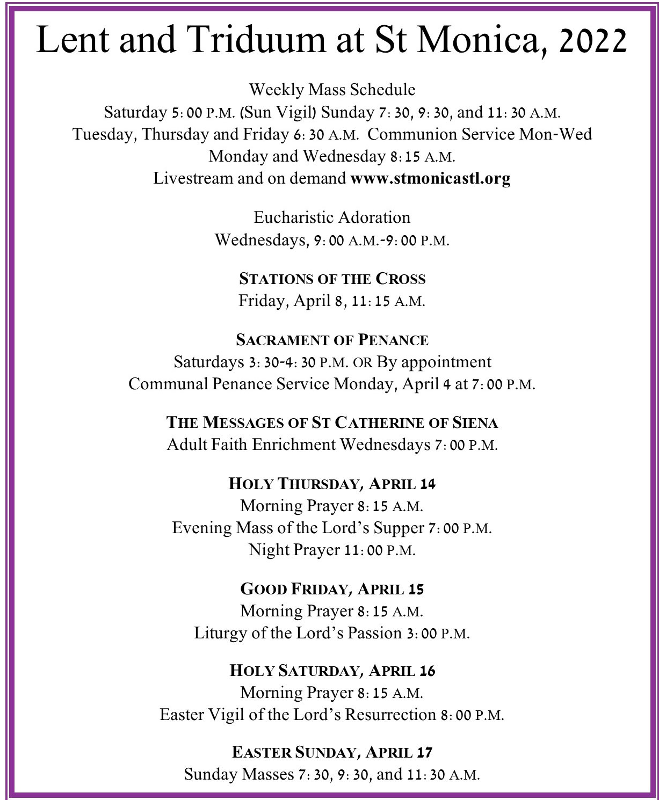
ALL THINGS NEW - DISCIPLE MAKER INDEX SURVEY
As part of the St. Louis Archdiocese strategic planning effort, this is your chance to pro- vide input into the process. The survey is open until April 4. Here is the link: https:// portal.catholicleaders.org/d/y3g48y Paper surveys are also available at the Parish Office. Do not miss your opportunity to provide feedback to Archdiocesan leaders!

St. Monica School Board is looking for four parishioners to join our team. The school board advises Fr. Wyrsch and our School Principal Mrs. Rohman in various matters that impact the school and the parish community. We ask that you prayerfully consider giving of your time and talent to help make our parish community stronger.

If you are interested in nominating yourself or another parishioner please scan the following and complete the short survey.

Thank you, Tim Voelkl
School Board President

WE NEED YOU!
Are you looking for a way to serve our community, but you are unsure where you are needed?
Here are a few ministries looking for additional volunteers:
NURSING HOME APOSTOLATE–If you are available during weekdays to visit the homebound in nursing homes or hospitals in the area, please contact Gene Adelmann at 314.722.2431.
ST. VINCENT DE PAUL–Seeking people of all skillsets to come and serve our neighbors in a variety of capacities. Contact Susan Hurt at 314-648-1332 for more information.
HOSPITALITY COMMITTEE–If you are able to help when there are events at the parish that require setup and clean up, contact Diann Bomkamp dbomkamp@sbcglobal.net. Volunteers are especially needed for the upcoming Easter weekend reception.
PRO-LIFE – Donors are currently needed for the May 1st Blood Drive. Contact Diann Bomkamp

at dbomkamp@sbcglobal.net or sign up at https://login.bloodcenter.org/donor/schedules/

Heal your Back without Surgery!

Get this weekly bulletin delivered by
email - for FREE!
Sign up here:
www.jspaluch.com/subscribe
Courtesy of J.S. Paluch Company, Inc.
- Herniated Disc
- Leg/Foot numbness
- Pain with Sneezing Sung Kwang Lee, DC 314-995-9704
www.stlchiropractor.net 677 N New Ballas Rd. Ste 220 Creve Coeur, MO 63141

www.ParcProvence.com

So Many Options, One Obvious Choice for dementia and Alzheimer’s care
Call 314.542.2500 to schedule a tour.
605 Coeur De Ville Dr. Creve Coeur, MO 63141
We are committed to equal housing opportunity that does not discriminate in housing and services because of race, color, religion, sex, handicap, familial status or national origin.
- Medical & Cosmetic Dermatology
- Botox®, Dysport® & Injectable Fillers
- Aesthetician-administered treatments also available
- Convenient Weekday & Weekend Appointments
314.878.0600
222 S. Woods Mill Rd. @ St. Luke’s Hospital www.MidAmericaSkin.com
Joseph A. Muccini, MD

INVEST LOCALLY
Targeting local business makes good “Cents”– Get your name out there by advertising in local parish bulletins. Contact us today for your next advertising move and we will work with you for your next “AD THAT WORKS!”
Check us out at www.jspaluch.com

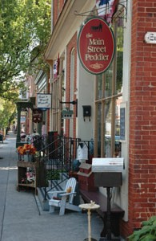GREAT REASONS to Patronize the Merchants in Our Church Bulletin!
5

They support the work of our church.
- It keeps money in our community. For every $100 spent at a locally owned business, $68 goes back into the community and your tax base. For every $100 spent at a chain store, only $43 comes back. Online purchases bring nothing back to our local community.
- Keeps our community unique. Where we shop, where we eat and have fun—all of it makes our community home. Our one-of-a-kind businesses are an integral part
of the distinctive character of our community.
- Creates more good jobs. Small local businesses are the largest employer nationally and in our community.
- Get better service. Local businesses often hire people with a better
understanding of the products they are selling and take more time to get to know customers.
The Sponsors Who Appear On This Bulletin.
It Is Through Their Support That This Bulletin Is Made Possible.
Business Owners Interested In Advertising Please Call
J.S. Paluch at 1-855-685-5703
957061 St Monica Church (B) www.jspaluch.com For Ads: J.S. Paluch Co., Inc. 1-855-685-5703

  - Fully Insured
- Free Estimates
966-8206 St. Clement Parishioner
www.andresroofing.com

Craft Supplies and Personalized Gifts
Nancy Young Scheberle, Parishioner
314.485.1112
12941 Olive Blvd.
(Fee Fee & Olive in Olive Arcade Plaza)
*ask for parishioner discount*

Bathroom Remodeling

(314) 895-3433
$20 OFF
Tree Pruning / Removal / Fertilization
314-782-5328 | davey.com

Your ad could
be in this space!

C.E.S.
PEST & TERMITE CONTROL, INC.
(314) 353-1101
FAX (314) 353-3505
Craig D. Aldridge II, CEO
8620 Gravois Rd. St. Louis, MO 63123

Consider Remembering Your Parish in Your Will. For further information, please call the Parish Office.

Catholic Cruises and Tours and The Apostleship ® ®

of the Sea of the United States of America
(CST 2117990-70)
Take your FAITH ON A JOURNEY.
Call us today at 860-399-1785 or email
eileen@CatholicCruisesandTours.com
www.CatholicCruisesandTours.com

Joe Gibson, CFP
Financial Advisor
711 N. New Ballas Rd. St. Louis, MO 63141

, AAMS

Goldkamp Family, Parishioners
www.designaire.net 314-739-1600

Joe.Gibson@EdwardJones.com
314-567-7293

PARISHIONER www.edwardjones.com

For Over 20 Years, Trusted Professional Home Care Services
(314) 965-4350
Denise Huber & Eileen Hedrick
Co-Founders
www.marthashands.com

Grow in your faith, find a Mass, and connect with your Catholic Community with OneParish!
Say Good-bye to Clogged Gutters!

- LeafGuard®
Receive a $50 restaurant gift card with in-home estimate
& free gutter inspection!
Consumer Disclosure/Award Rules: All participants who attend an estimated 60-90 minute in-home product consultation will receive a $50 gift card. No purchase is necessary. Retail value is $50. Offer sponsored by LeafGuard Holdings, Inc. Limit one gift card per household. LeafGuard procures, sells, and installs seamless gutter protection. This offer is valid for homeowners over 18 years of age. If married or have a life partner, both cohabitating persons must attend and complete presentation together. Participants must have a valid photo ID, understand English, and be legally able to enter into a contract. The following persons are not eligible for this offer: employees of LeafGuard or affiliated companies or entities, their immediate family members, previous participants in a LeafGuard in-home consultation within the past 12 months and all current and former LeafGuard customers. Promotion may not be extended, transferred, or substituted except that LeafGuard may substitute a gift card of equal or greater value if it deems it necessary. Gift card and terms and conditions (https://www.darden.com/gift-cards/terms-and-conditions) of such gift card will be mailed to the participant via first class US Mail within 21 days of receipt of promotion form provided at consultation. Not valid in conjunction with any other promotion or discount of any kind. Offer not sponsored or promoted by Darden Restaurants and is subject to change without notice prior to reservation. Offer ends 3/31/2022.
is guaranteed never to clog or we’ll clean it for FREE*
- Seamless, one-piece system keeps out leaves, pine needles, and debris
- Eliminates the risk of falling off a ladder to clean clogged gutters
- Durable, all-weather tested system not a flimsy attachment

Download Our Free App or Visit
Call today for your FREE estimate and in-home demonstration

*Guaranteed not to clog for as long as you own your home,
$99
Installation*

*Does not include cost of material. Expires 3/31/22.
or we’ll clean your gutters for free.

12444 Olive Blvd. Creve Coeur, MO (314) 514-1111
Funeral Directors Since 1935 Family Owned and Operated Mike Stipanovich, Parishioner
https://www.oneparish.com
CALL NOW 314-549-8449 _{Get} _{it.} _{And} _{forget} _{it.}®
– FIELDER – ELECTRICAL SERVICES, INC.
LICENSED • BONDED • INSURED RESIDENTIAL • COMMERCIAL • INDUSTRIAL
Service Upgrades • New Homes • Remodeling • Room Additions • Basements • Kitchens Bathrooms • Code Violations • Knob & Tube Upgrades • Back Up Generator Systems

$20OFF Any Electrical Work of $100 or more 314-966-3388

JOHN GILLIAM, Inventory Manager
“Call or Email Me Directly”
314.434.5000 C: 314.952.1666
jgilliam@seegertoyota.com • 12833 Olive St. Rd., Creve Coeur, MO

What We Can Offer You and Your Business:
  - Many ad size options to meet your budget in color or black and white
  - One-on-one customer service to help build and design your ad
  - The ability to change your ad up to 12 times per year
J.S. Paluch Company 1.855.685.5703
WHY IS IT
A man wakes up after sleeping under an ADVERTISED blanket on an ADVERTISED mattress
and pulls off ADVERTISED pajamas bathes in an ADVERTISED shower shaves with an ADVERTISED razor brushes his teeth
with ADVERTISED toothpaste washes with ADVERTISED soap puts on ADVERTISED clothes drinks a cup
of ADVERTISED coffee drives to work
in an ADVERTISED car and then . . . .
refuses to ADVERTISE
believing it doesn’t pay. Later if business is poor

RELIGIOUS GIFTS & DECOR | SCHOOL UNIFORMS | BOOKS & BIBLES STATUARY | NATIVITIES | CHURCH SUPPLIES | CANDLES
SEASONAL & SACRAMENTAL GIFTS
ST. LOUIS HILLS O’FALLON, MO
6759 Chippewa Street 2985 Hwy K
(at Jamieson, across from Ted Drewes) (at Hwy N, near Dierbergs)
St. Louis, MO 63109 O’Fallon, MO 63368
(314) 644-0643 (636) 379-3705
SHOP ONLINE! catholicsupply.com
If You Live Alone You Need MDMedAlert!
24 Hour Protection at HOME and AWAY!

he ADVERTISES it for sale.
✔Ambulance
✔Police ✔Fire
Friends/Family
Solutions as Low as $19.95 a month

The Most Complete Online National
WHY IS IT?
✔ FREE Shipping
FREE Activation
NO Long Term Contracts
CALL
800.809.3352

This Button SAVES Lives!
As Shown GPS, Lowest Price Guaranteed!

Directory of
NOW! GPS Tracking w/Fall Detection
Nationwide, No Land Line Needed

Check It Out Today!
Catholic Parishes
MDMedAlert
Safe-Guarding America’s Seniors Nationwide!
EASY Set-up, NO Contract
24/7 365 Monitoring in the USA

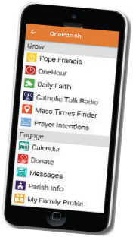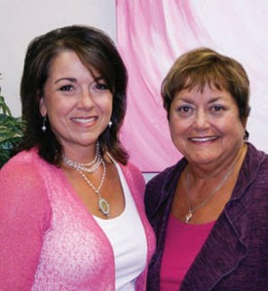957061 St Monica Church (A) www.jspaluch.com For Ads: J.S. Paluch Co., Inc. 1-855-685-5703

